**Final Project Requirement**

Deadline: March 11, 2021 (Thursday)

For this final project, we will create a simple COVID exposure tracker tool that will monitor our exposure to places and people for the last 14 days. It tracks whether you had practiced social distancing or been on a crowded places for the last 14 days. No exposure for the last 14 days means you are relatively safe and well isolated from the virus.  
  
We will use MERN (MongoDB/Expres/React/NodeJs) stack for this final project. The M, E and N are already provided via this [repository](https://github.com/MagenicManilaFrontEndDev/CovidTracker). Our back-end is using MongoDB as database, Express for easy API coding and Node for hosting our web APIs. You will provide the R, which is the React part of the project.

**Page #1: Dashboard**

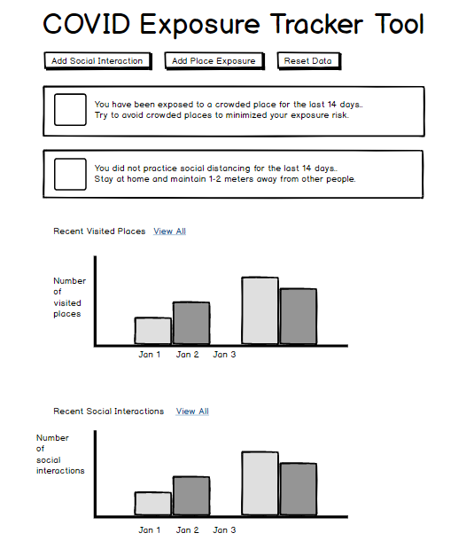

**Image 1**

**Requirements**

**Buttons**

* Create a UI that will display a page similar to **Image 1**
* **Add Social Interaction** and **Add Place Exposure** buttons will display a pop-up that will enable the user to add new record respectively

**Charts**

* Dashboard will display a chart that shows Visited Places for the **last 7 days**

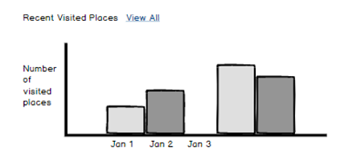

* Clicking the View All link will show the **Visited Places master list page** (**Image 2**)
* Dashboard will display a chart that shows Social Interactions for the **last 7 days**
* Clicking the View All link will show the Social Interaction master list page (**Image 3**)
* You may use any charting library for React

**Pinned Notifications**

* If the user has been exposed to a crowded place for the last 14 days, this notification will be displayed below the buttons. Use exclamation icon on space provided on the left.

Use red color for this notification

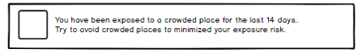

* Else, this notification will be displayed. Icon should be info and the color of the notification should be green

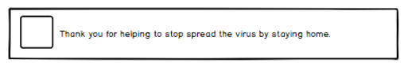

* If the user has social interaction and did not practiced social distancing for the last 14 days, this notification will be displayed below the buttons. Use exclamation icon on space provided on the left. Use red color for this notification



* Else, this notification will be displayed. Icon should be info and the color of the notification should be green

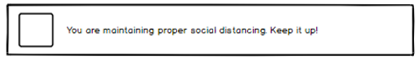

**Page #2: Visited Places Master List**

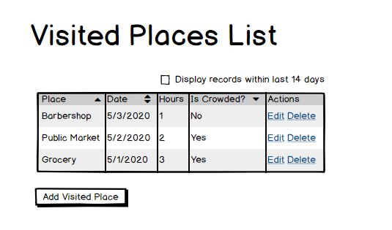

**Image 2**

**Requirements**

**Buttons/Actions**

* Add Visited Place will display a pop-up modal similar to **Image 4**
* Clicking the **Edit** link will change the row of selected record from label to textbox. Edit and Delete link will then be replaced with **Update** and **Cancel**
* Clicking the **Delete** link will delete the record
* **Display records withink last 14 days** check box (located on the top right) is unchecked by default
* When **Display records withink last 14 days** is checked, the grid will only display records for the last 14 days
* When **Display records withink last 14 days** is unchecked, the grid will display all records on database

**Grid**

* Use any grid library that will present the data similar to **Image 2**
* If **Is Crowded** is true on the record, the row will be highlighted in red
* Sorting and Paging is a bonus (+10)

**Page #3: Social Interactions Master List**

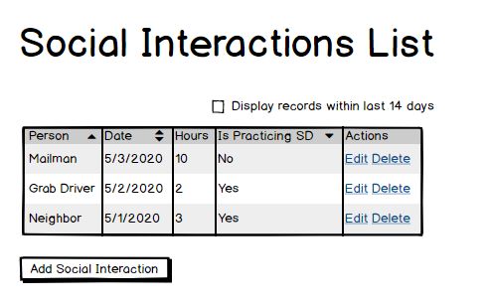

**Image 3**

**Requirements**

**Buttons/Actions**

* Add Social Interaction will display a pop-up modal similar to **Image 5**
* Clicking the **Edit** link will change the row of selected record from label to textbox. Edit and Delete link will then be replaced with **Update** and **Cancel**
* Clicking the **Delete** link will delete the record
* **Display records withink last 14 days** check box (located on the top right) is unchecked by default
* When **Display records withink last 14 days** is checked, the grid will only display records for the last 14 days
* When **Display records withink last 14 days** is unchecked, the grid will display all records on database

**Grid**

* Use any grid library that will present the data similar to **Image 3**
* If **Is Practicing Social Distancing** is false on the record, the row will be highlighted in red

**Page (Modal) #4: Add Visited Place Pop-up Modal**

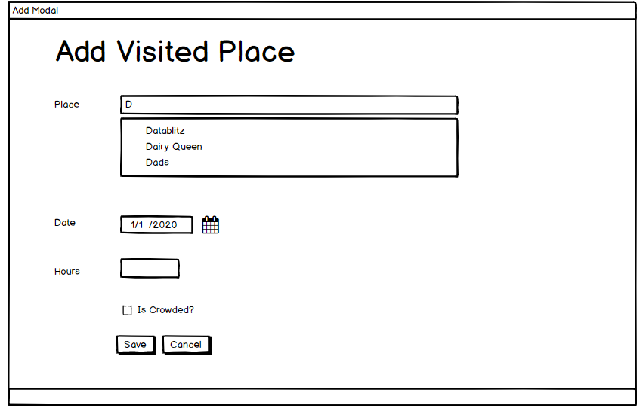

**Image 4**

**Requirements**

**Buttons**

* Clicking the Save button will run the validation. If there is no validation error, the entry will be saved and the pop-up will close
* Clicking cancel button will close the pop-up modal (thanks Captain Obvious 😊)

**Form**

* All fields are required. Display an inline validation error message if validation fails
* The **place** text box should provide suggestions based on existing records. Clicking the suggested record will put that value on the **place** field.
  + Ex. There are existing records for “Grocery”, “Market” and “Coffee Shop”. If the user entered “Co” on the place input text, it should suggest “Coffee Shop”

**Page (Modal) #5: Add Social Interaction Pop-up Modal**

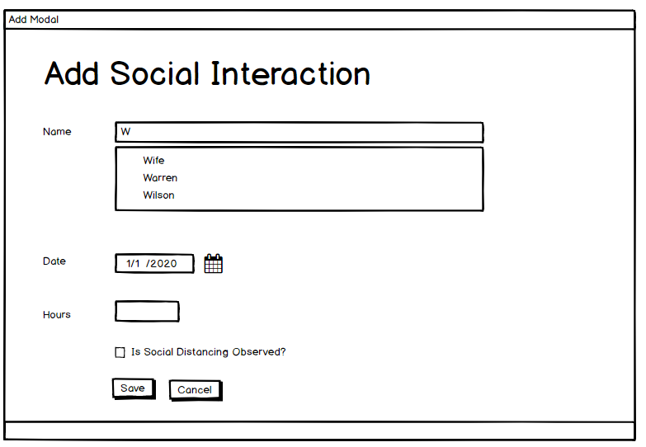

**Image 5**

**Requirements**

**Buttons**

* Clicking the Save button will run the validation. If there is no validation error, the entry will be saved and the pop-up will close
* Clicking cancel button will close the pop-up modal (again, thanks Captain Obvious 😊)

**Form**

* All fields are required. Display an inline validation error message if validation fails
* The **Name** text box should provide suggestions based on existing records. Clicking the suggested record will put that value on the **place** field.
  + Ex. There are existing records for “Ned”, “Robert” and “Rhaegar”. If the user entered “R” on the place input text, it should suggest “Robert” and “Rhaegar” since they all starts with letter “R”

**Technical Details**

* You can clone the initial project at <https://github.com/MagenicManilaFrontEndDev/CovidTracker>
* Feel free to create a fork if you want to modify the back-end
* The client app runs on port 3000
* The web API runs on port 5000
* You need to setup your own MongoDB database. Refer to appendix for steps on creating your own MongoDB
* The proctor is responsible for updating the back-end. If you think there are missing endpoints, feel free to discuss it to the proctors
* You can install **Rest Client** VS Code extension to use the .rest files for testing the API endpoints

**Setting Up MongoDB**

* Go to <https://www.mongodb.com/> and go to Sign Up

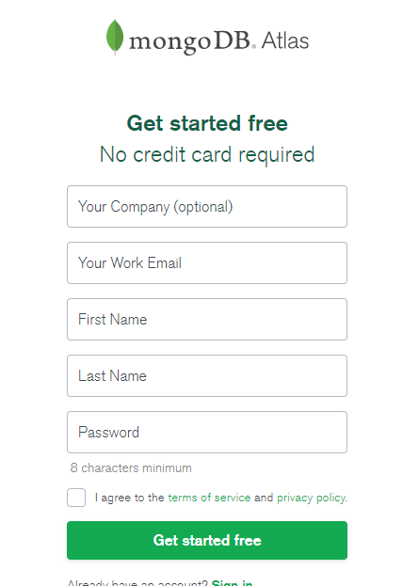

* Choose Shared Clusters

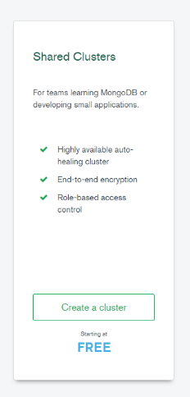

* + **Change the cluster name to “CovidCluster”**

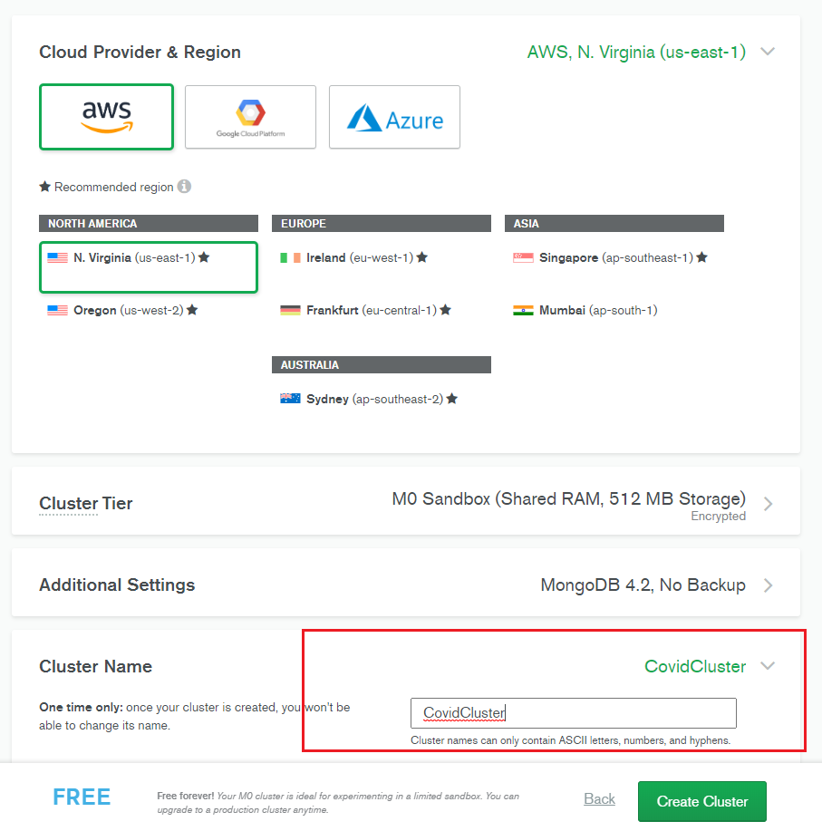

* Creating cluster takes a while (usually 3 mins)

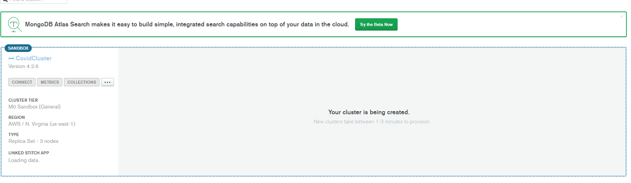

* After few minutes, your cluster and DB should be available. The next step is to add user that we will use for our connection string.

**Setting Up DB User**

* Under security menu, click Database Access
* Click add new database user and fill-up the form
  + Select **Password** as Authentication Method
  + Select **Read and Write** for DB user privileges

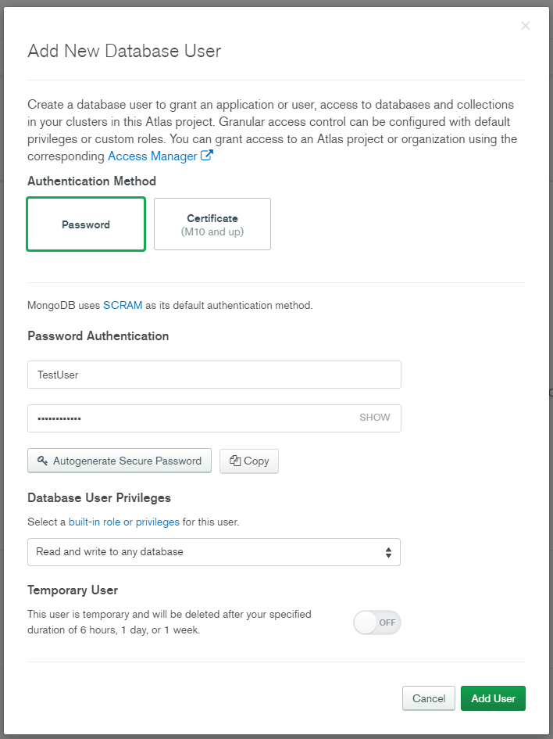

**Setting Up IP Whitelist**

* Under security menu, click Network Access
* Click Add IP Address
* To simplify IP Address restrictions, click **Allow Access From Anywhere**

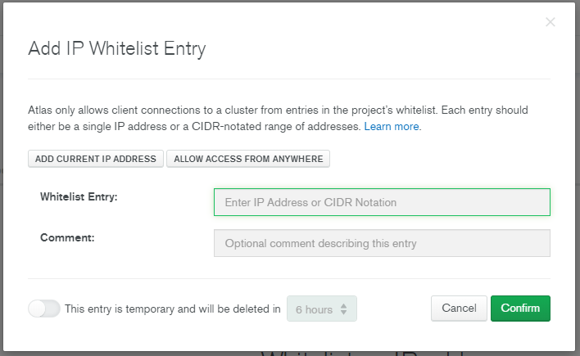

**Getting Connection String**

* Return to Clusters and click Connect button

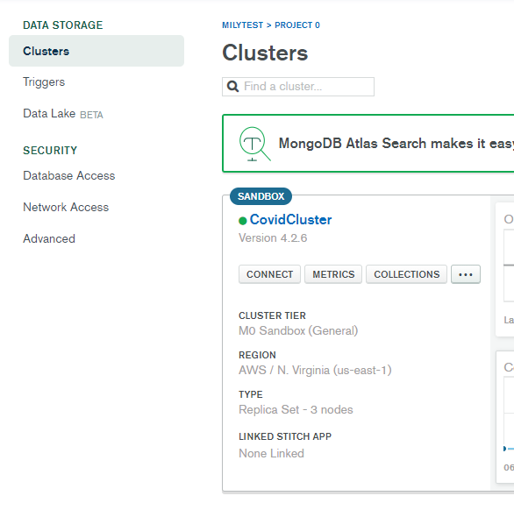

* Select **Connect Your Application**
* Click the copy button to copy your connection string

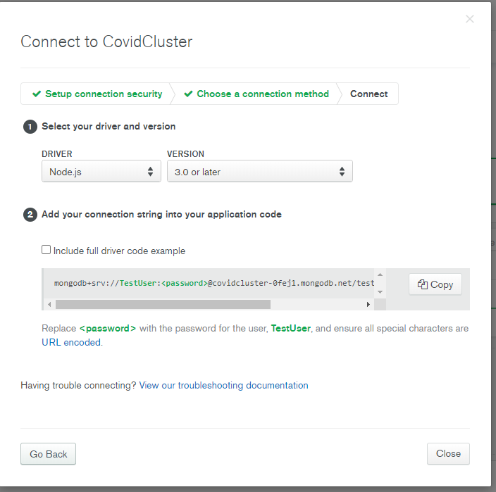

* Open the CovidTracker boilerplate app and locate config\default.json
* Replace the mongoURI entry with your generated connection string. Make sure to change the <password> part.

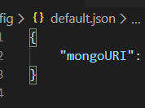

* Run the application. The console should show “MongoDB Connected”